

|  |  |
| --- | --- |
| **Assessment Details and Submission Guidelines** | |
| **Trimester** | T1 2022 |
| **Unit Code** | BN109 |
| **Unit Title** | Web and Multimedia Systems |
| **Assessment Type** | Assignment 2 (Individual) |
| **Assessment Title** | To design and develop a ***personal website***. |
| **Purpose of the**  **assessment**  **(with ULO Mapping)** | Student should be able to:   1. Analyse client needs and create effective navigation for Web sites 2. Apply good design and coding practices to ensure the standards-compliance, presentation, and usefulness of Web and multimedia content |
| **Weight** | 35% |
| **Total Marks** | 100 |
| **Word limit** | NA |
| **Due Date** | Week 11 (3/06/2022) 11:59 PM |
| **Submission**  **Guidelines** | • All work must be submitted on Moodle by the due date along with a completed Assignment Cover Page.  • The assignment must be in MS Word format, 1.5 spacing, 12-pt Times Mew Roman (Body) font and 2 cm margins on all four sides of your page with appropriate section headings.  • Reference sources must be cited in the text of the report, and listed appropriately at the end in a reference list using IEEE referencing style. |
| **Extension** | • If an extension of time to submit work is required, a Special Consideration  Application must be submitted directly to the School's Administration at level  6 or level 7 for Sydney. You must submit this application three working days prior to the due date of the assignment. Further information is available at: <https://www.mit.edu.au/about-us/governance/institute-rules-policies-and-plans/policies-procedures-and-guidelines/assessment-policy> |
| **Academic**  **Misconduct** | • Academic Misconduct is a serious offence. Depending on the seriousness of the case, penalties can vary from a written warning or zero marks to exclusion  from the course or rescinding the degree. Students should make themselves familiar with the full policy and procedure available at: [**http://www.mit.edu.au/about-mit/institute-publications/policies- procedures-and-guidelines/Plagiarism-Academic-Misconduct-Policy- Procedure**](http://www.mit.edu.au/about-mit/institute-publications/policies-procedures-and-guidelines/Plagiarism-Academic-Misconduct-Policy-Procedure). For further information, please refer to the Academic Integrity Section in your Unit Description. |

**Description of the assessment:**

Please read the following specification (see table 1) and prepare a personal website to showcase your IT skills to prospective employer(s). Please note that use of template downloaded from other sources will not be accepted, e.g., Bootstrap and other templates like HTML boilerplates or Wix.

**Part A (Specification):**

This assignment consists of two parts. For part A, you need to prepare a collage (see in table below; highlighted and bolded). Download the zipped file named “Images_Collage_T12022.zip” and prepare the collage that looks similar to given collage (must have close match for good credit). Use this collage (**only**) to create Digital Images.html page. **Any other image that is not the collage created as part of this assignment will attract zero marks.**

**Sample of collage (size of finished collage = 600px * 400px):**

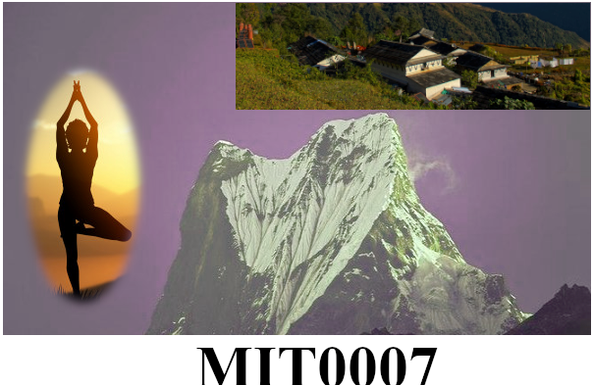

Figure 1 Completed Collage

**Marking guide for part A**

|  |  |  |
| --- | --- | --- |
| Description of the section | Weight | Marks |
| PART B |  | 30 |
| Correct canvas size (MUST be 600px * 400px) | 2 |  |
| Main background with HSV (Hue, Saturation and Lightness model applied). Use the parameters as H = 61.5, L=17.1 and S=-7.9 to get this background | 5 |  |
| Background with Yoga Posture (see sample provided – use appropriate feather value) | 5 |  |
| Background of village – need to cropped from given image (ghandruk-village-trek.jpg) | 5 |  |
| Student ID number with correct font-family (Serif-bold); judge the font-size to get to close to sample provided including white background | 5 |  |
| Word document that contains steps to create above collage. | 8 |  |
| Sub-Total | **30** |  |
| ***Negligent effort: Final collage does not resemble to sample provided and students failed to supply .xcf file. Create the collage using multiple named layer.***  ***Absence of layer and .xcf file*** | **0** |  |

**Part B** consists of creating your personal website as detailed below.

**Assignment task (Website development):**

**Table 1: Specification for a proposed website**

|  |  |
| --- | --- |
| Page | Requirement |
| Home page (index.html) | This page should have a logo (design your own logo), a unique tagline  (Few words to explain the uniqueness to describe the website).  Please design your unique favicon that goes with respective page title.  You may include your image and your goals you want to achieve in future. |
| Education (education.html) | Write a brief description of yourself on maximum academic qualification you have achieved so far. You may mention your high school education and the program you are currently enrolled. |
| Digital Images (collage.html) | Use this page to display collage that **you’ve created for** **assignment** 1. Write brief summary of how you prepare collage. Collage and other images should have neat caption below them. Provide alternative text for every images/non-text media. See example in appendix at the end of this document. |
| Digital Video (video.html) | Insert a **video you have edited and developed in laboratory 10 using HTML video tags**. Write on how you have worked out from original video (raw video) to create this video. Any other video will attract 0 marks for this section. |
| Skills (skills.html) | Use this page to indicate skills you require to have to as an employable IT career. Embed a YouTube video relevant to skills required for a web developer. |
| Contact Us (contact.html) | Use this page to display appropriate form elements to get users’ details, comments and inquiry. When data is submitted display a “Thank you” page (this may not be fully functional) |
| Footer (Not a separate page but part of all the pages) | Insert the Copyright information, useful links like disclaimer, privacy policy and social media links with relevant medias. |

**Marking criteria:**

|  |  |  |  |
| --- | --- | --- | --- |
| Topic | Descriptions |  | Marks |
| Home | A unique logo, a tagline and favicon with appropriate page title (**5 Marks**).  Maximum of a paragraph of text to tell users of your goals/achievements in future. Provide complimentary image(s) complete with caption (**5 marks**) | | **10** |
| Education (education.html) | Must contain the following:  •  Highest qualification  •  Image(s) with caption | | **5** |
| Digital Images (collage.html) | Must contain the following:   * PNG/JPG image as completed collage file (from 1B) * Brief description of steps to create above collage | | **5** |
| Digital video (video.html) | Must contain the following:   * HTML5 video edited in Lab10 * Brief steps to create above video highlighting the use of transition | | **5** |
| Skills (slii.html) | Must contain the following:   * Skill sets specific to chosen IT Career * An embedded YouTube video matching at least a skill sets mentioned. | | **5** |
| Contact Us (contact.html) | Must contain the following:   * Fully formatted page that has appropriate form elements (including **email** of users) (**6 Marks**) * A thank you page when “submit button is clicked (**4 Marks**) | | **10** |
| Overall Creativity | All pages are consistent in look and feel contains unique page title along with favicons. Unnecessary animation and “text-marquee” may attract seduction of marks in relevant pages. | | **10** |
| HTML and CSS | Evidence of use of semantic HTML tags and external CSS | | **20** |
| **Sub Total (website)** |  | | **70** |
| **Sub Total (collage – Part A)** |  | | **30** |
| **Total** |  | | **100** |